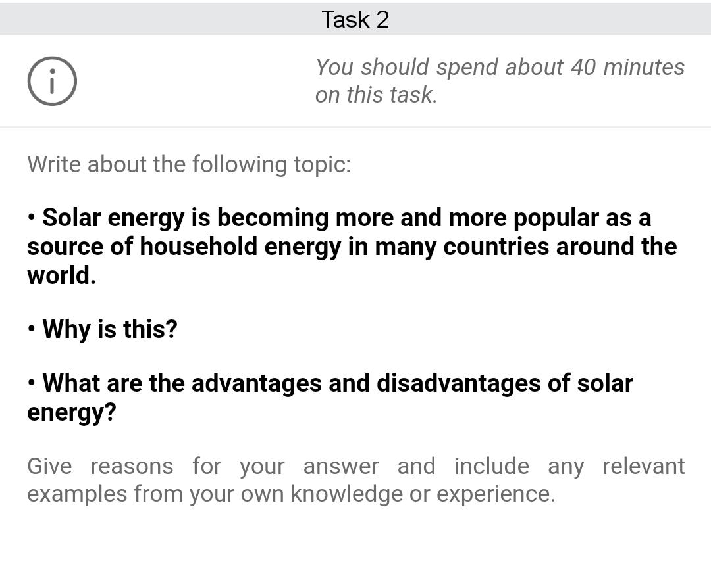

Nowadays, it is evident that solar technology is more famous than in previous centuries for day-to-day uses in a home. Although there are multiple reasons which govern this, we cannot judge this before seeing both sides of a coin.

Firstly, Let us have a brief overview of the past and the reasons behind the popularity of this technology. With rapid development in the 19th and 20th centuries, we developed engineered systems. Though we were aware that they would be helpful for humans by all means, there was an immense cost we were unaware of, however, the price paid was not merely only the time, and passion but environmental pollution and resources. As we stepped into the 21st century, we paid it in terms of huge catastrophic environmental changes across the globe. In order to take control of the United Nations developed strategic development goals for the future. These goals would help us to develop a sustainable and friendly environment not only for us but living creatures around us. This led us to adapt to environmentally friendly technology, furthermore, the government is also involved in all means.

The main factors of inclination toward this technology are the benefits-to-cost ratio. One of the main reasons is that it neither harms the environment nor it costs a lot. In addition to that the government is providing incentives to install solar in their home. Not only that there is independence in using that and you are no longer bound to it.

Let us not forget the other side of the coin. Although it comes with great benefits the negative aspects should not be neglected. The costs of manufacturing this sturdy and long-lasting technology are huge and at the root level, it costs consumers. Apart from that, production can hurt the environment indirectly.

Keeping both sides in mind, It seems that advantages weigh much more than disadvantages. It is a great technology with immense capability to transform the environment into a friendly environment.

This bar graph demonstrates the percentages of men and women; It also compares their percentages with each other. According to the helicopter view, this illustrates that male staff exceeds in science, engineering and business field. Whereas the female staff members are more in education, arts but medicine is the subject where percentages are somewhat similar.

The male-dominated subjects showed a noticeable difference in percentage. The engineering was highest of all of them where they were 85% and females were 15%. The Lowest of them was law where males are 20% ahead of females, whereas females are at 40%.

Whereas for female-dominated subjects there was a very minute difference except for education. Although the percentage of females in education was 75% whereas men were at 25%. Apart from that there was a difference of 10% and around 2% for arts and medicine respectively.